URL: <http://www.cellport.jp/english/>

Our mission:

Cellport Clinic Yokohama is a medical institution that offers advanced cosmetic surgery. Successful advanced cosmetic surgery starts with the patient's wishes. Cellport Clinic Yokohama will closely listen to the patient's requests and offer concrete solutions.

Cellport Clinic Yokohama provides medical treatments that use the patient's own Adipocytes. We have equipped the clinic with medical and cell processing facilities that are necessary for this advanced treatment, and we have arranged a system that can provide medical treatment with a high level of safety and effectiveness.

We will provide medical services with a personal touch. We will make every effort in order for the patient to have a comfortable stay at the clinic.

To respond exactly to the patient's request using advanced medical techniques and unparalleled hospitality. That is our mission.

Procedures:

1. Breast augmentation
2. Removing silicone implant and breast augmentation
3. Breast reconstruction and breast cancer surgery
4. Progressive facial hemi atrophy reconstruction
5. Facing (anti-aging)
6. Buttock lift

Doctor’s credentials

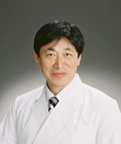 Okazaki Kaoru Director of anesthesia

|  |
| --- |
| Graduate from Yokohama City University, School of Medicine, 1976, After serving as resident at Yokohama City University Hospital, serve as assistant at Department of Anesthesiology / Chief of Intensive Care Unit, 1976 |
| UCLA, Department of Anesthesiology, researcher, 1985 |
| Yokohama City University Hospital Operation Department, doctor / lecturer, 1986 |
| Yokohama City University Medical Center, Director of Anesthesia / associate professor, 2002 |
| Cellport Clinic Yokohama, 2008 |

* Japanese Society of Anesthesiologists
* The Japanese Society of Intensive Care Medicine
* The Japanese Respiratory Society

http://www.cellport.jp/english/img/doctor_comment_bottom.jpg

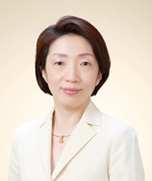 Asano Yuko

University of Occupational and Environmental Health, School of Medicine, 1990  
Japanese Red Cross Medical Center, 1990 Department of Plastic and Reconstructive Surgery, the University of Tokyo, 1992

Employed in Jichi Medical University Hospital, Musashino Red Cross Hospital, and International Medical Center of Japan specializing in plastic surgery, and from April, 2000, the Fraternity Memorial Hospital.

Cellport Clinic Yokohama, 2008

* Board Certification
* Plastic Surgery

Photos

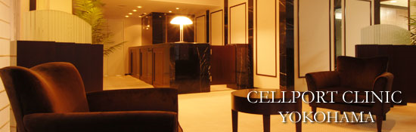

Contact us

Yokohama Excellent III 2F

,Minaminakadori 3-35,

Naka-ku, Yokohama,

Kanagawa, Japan,  
231-0006